ANNOUNCEMENTS – April 28, 2024
April 28 – CLC Worship 8:30
SJL Worship 10:30
May 04 – Dan Young graduates for Lay School of Ministry
Saturday, May 4, 2024 at 1:00 p.m.
Zion Lutheran Church in Shawano
May 05 – Joint Service at 10:00 Schairer’s Farm Shop
May 06 – CLC Quilting 9:00
May 07 – CLC Council Meeting
May 08 – CLC FOOD WITH FRIENDS Last one until Fall
Your help is always needed and appreciated
Maybe work at the dinner or make a dessert
May 09 – Birnamwood Outreach
SJL WELCA Meeting and Bible Study 2:00
SJL Council Meeting 6:00
May 12 – We will continue with the current worship times thru
the end of May
CLC Worship 8:30 a.m.
Coffee Fellowship and celebration of Dan Young’s
Graduation from Lay School of Ministry
SJL Worship 10:30 a.m.
May 19 – Pentecost Sunday and Confirmation Sunday CLC/SJL
CLC Worship 8:30 a.m. with Communion (Noisy Offering)
SJL Worship 10:30 a.m. with Communion
Please note: Service Schedule
new time changes in May
and summer schedule

May 05 – 10:00 JOINT SERVICE at Schairer’s Farms Shop
May 12 thru 26 service times will remain the same until the end of
May CLC 8:30 SJL 10:30

June 2 thru August we will have a summer schedule:
SJL 7:00 p.m. on Wednesday Evenings
No Sunday Services
CLC 9:00 a.m. each Sunday

We are trying to accommodate the wishes of our two parishes and
make things easier for our Pastor. You are invited to attend either the Wednesday 7:00 p.m. service at St. John’s or the Sunday service at 9:00 a.m. at Calvary. Both churches welcome you. Your donations (in marked envelope) will be sent to your home congregation.

Fifth Sunday of Easter
April 28, 2024
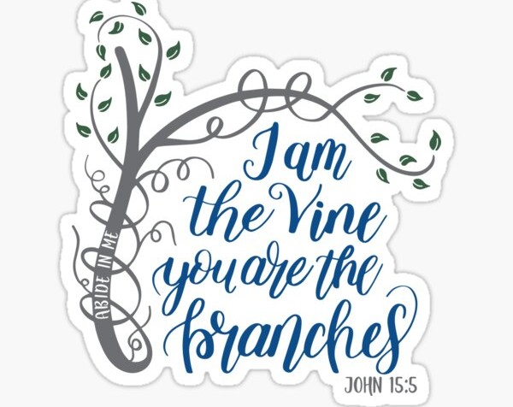

“On the night of his arrest, Jesus taught his disciples about the relationship they would have with him. Those who abide in his word and love bear fruit, for apart from him, they can do nothing.”

KINDRED LUTHERAN PARISH
Pastor Jennifer Sosinski – 715-219-5489
Email:vicarjennifer@outlook.com

Calvary Lutheran Church (8:30 a.m.)
310 S. Superior St. – Antigo WI 54409
Phone: 715-623-3102
Email: calvary.antigo@gmail.com
Organist: Becky Rotzoll Lector: Robin Gardner
Song Leader: Peggy Benes

St. John’s Lutheran (10:30 a.m.)
W17680 Church Road – Birnamwood WI 54414
Contact: Pastor Jennifer or Wayne Clark: 715-449-2341
Email: stjohnlutheranchurch54414@gmail.com
Pianist: Barb Nelson

Kindred: Power Point Presenter: Linda Grall from CLC

We follow Jesus Christ by welcoming everyone, growing in faith, serving
God and others, and walking with God’s people
Fifth Sundy of Easter – April 28, 2024
Setting 4 in the Evangelical Lutheran Worship (ELW) Hymnal page 147

Prelude
Call to Worship
Welcome and announcements

GATHERING
Confession and Forgiveness back cover of hymnal

Hymn: “Now All The Vault of Heaven Resounds” #367

P: The grace of our Lord Jesus Christ, the love of God, and the communion of the holy Spirit be with you all.
C: And also with you.

The Kyrie p.147
Hymn of Praise: “Glory to God in the Highest. . . “ p.148

The Prayer of the Day (in unison see Celebrate insert)
WORD
Readings as found in the Celebrate Insert
First Reading: Acts 8:26-40
R: The Word of the Lord All: Thanks be to God.
Responsive Reading: Psalm 22:25-31
Begin with refrain and repeat after the bold R
Second Reading: 1 John 4:7-21
R: The Word of the Lord. All: Thanks be to God.

Gospel Acclamation p.151
“Alleluia, Lord to who shall we go? You have the words of eternal life. Alleluia.”
The Holy Gospel according to John 15:1-8
All: Glory to you, O Lord.
The Reading
Gospel of the Lord. All: Praise to you, O Christ.

Children’s Message
The Sermon – Pastor Jennifer Sosinski

Hymn of the Day: “O God, Our Help in Ages Past” (vs 1-4) #632

The Apostles’ Creed (found in the back of the hymnal)

The Prayers of Intercession (Celebrate Insert)
L: God of Grace, Response: hear our prayer.

The peace of the Lord be with you always. C: and, also with you
share the peace with one another

The Offering
CLC: Offertory Hymn: “All That We Have” in the blue folder
SJL: The Doxology

The Offertory Prayer
The Lord’s Prayer (in unison) p.154

SENDING
Please remain seated for the Blessing, Sending Hymn, and Dismissal.

The Blessing
Sending Hymn: “Let All Things Now Living” #881

(Candles are extinguished during last verse of hymn)

The Dismissal Response: Thanks be to God.
Postlude

Kindred Lutheran Parish Prayer List:
V CLC: Reed Kuenzli, Beth Wandrey, Jean Guse, Alice Shepherd, Brian Bauknecht, Tom Carpenter, Shane Wurtinger, Eric Bussiere, Melanie Godleske, Maverick Clark, Suzy Dantuma, Jan Young, Theresa DeBroux, Nancy Klemp

V SJL: Jackie Pukall, Kurt Olson, Jim Nelson, Patricia McCormick, Dave Carlson, Virginia Breyer, Earl Schmidt, Paula VanderGrinten, Brenda Zastrow, Joel Creydt, Bob G., Eric DeHart, Danielle (Hegewald) Andrews

V Prayers for members & friends serving in the military:
Greg, Joe, David, Kari, Isabel, Daniel, Padraic, and William Ryan.

**Please help to keep our Prayer Concerns List current: If you have placed someone on the prayer list and they are not a current member, please help to keep us informed of their current need to remain on the list.

